TASK 7 | ISPU IMPLEMENTATION OF QUAT+FE
  - Implementation evidence, model validation, communication, memory, and benchmark status
Status: demonstrated on LSM6DSO16IS ISPU and STM32F401RE; observed activity IDs 0 (Horizontal), 1 (Static), and 2 (Vertical). Quantitative ISPU timing and total power values still require hardware measurements. This appendix is designed to accompany the existing Tasks 1–6 report, not replace it.

1. System and implementation
Subsystem | Implementation / evidence
Hardware | NUCLEO-F401RE + X-NUCLEO-IKS4A1; LSM6DSO16IS with ISPU
IMU / ISPU | ±8 g acceleration; ±2000 dps gyro; native sensor/ISPU cycle 208 Hz
Quaternion fusion | Custom calibration-aware six-axis Madgwick C on ISPU; output w,x,y,z (displayed x,y,z,w)
Quaternion export | STM32 AlgoBuilder timer at 120 Hz; measured ~120.48–120.51 Hz in recorded sessions
Classifier | 42-sample windows, 21-sample stride; eight variance/peak-to-peak quaternion features; 17-node depth-4 tree
Classes | 0 Horizontal; 1 Static; 2 Vertical; 255 not ready
Communication | STM32F401RE polls 64 bytes of ISPU DOUT registers; USART2 921600 8-N-1 binary protocol to MEMS Studio
Architecture: IMU → Madgwick on ISPU → quaternion window & QUAT+FE decision tree on ISPU → 64-byte ISPU DOUT registers → STM32 timer-driven polling → MEMS Studio / UART. The STM32 does not perform Task 7 decision-tree inference.

2. Training and evaluation
Class | 120 Hz samples | Duration (s) | Rate (Hz)
Horizontal | 3655 | 30.321 | 120.51
Static | 3653 | 30.312 | 120.48
Vertical | 3659 | 30.361 | 120.48
The original appended log files contained earlier ~100 Hz runs. Only the later ~120 Hz sessions were extracted for training. A chronological per-recording split (60% train, 15% validation, 15% test, with gap segments) was used. This is a within-session evaluation, not independent repeated-trial validation.
Metric | Motion-feature tree | RFE comparison tree
Train accuracy | 288/307 (93.81%) | 290/307 (94.46%)
Validation accuracy | 75/78 (96.15%) | 78/78 (100%)
Test accuracy | 75/78 (96.15%) | 53/78 (67.95%)
Tree nodes / depth / leaves | 17 / 4 / 9 | 7 / 2 / 4
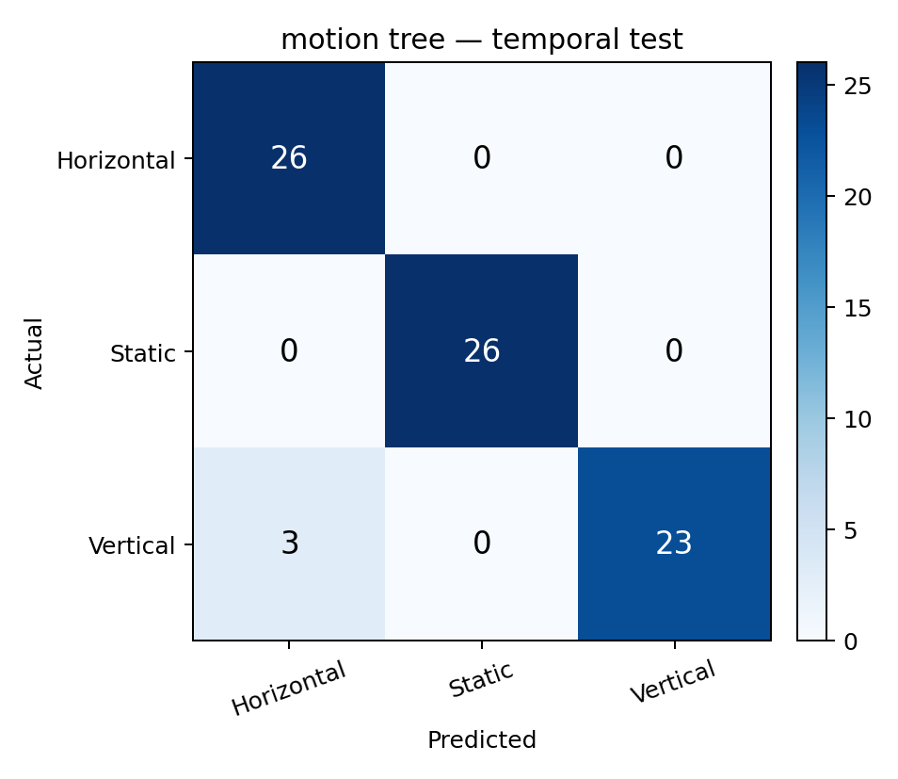
Figure T7-1. Chronological test confusion matrix; axes use model classes 0=Horizontal, 1=Static, 2=Vertical.
The test confusion matrix (true rows, predicted columns) is [[26,0,0],[0,26,0],[3,0,23]]: 75 of 78 windows classified correctly. Because different portions of the same activity recording appear in the splits, these results should not be interpreted as independent hardware accuracy.

3. Python/C reference validation
The bundled desktop checker reproduced the Python/JSON tree output using the generated C feature-extraction and traversal routines on 463 windows: 463/463 matched (100% agreement for that offline check). This establishes numerical equivalence of those implementations on the checked windows, not alignment with predictions captured from separate live ISPU trials.
The tree outputs a leaf-training-purity field as a heuristic quality indicator; it is NOT a calibrated probability of correctness. Fresh ground-truth-labeled hardware trials are still required for a live ISPU-vs-Python confusion matrix and agreement estimate.

4. Source files and compact tree representation
The accompanying package includes native C source and headers: ISPU_208hz/src/main.c, madgwick.c/.h, fusion_core.c/.h, and quat_fe_tree.c/.h, plus the STRED Makefile and sensor configuration. The decision-tree header defines QuatFeNode with feature, left/right children, threshold, predicted class and leaf training purity, and the C array has 17 nodes. Model JSON and training scripts are included for reproducibility.
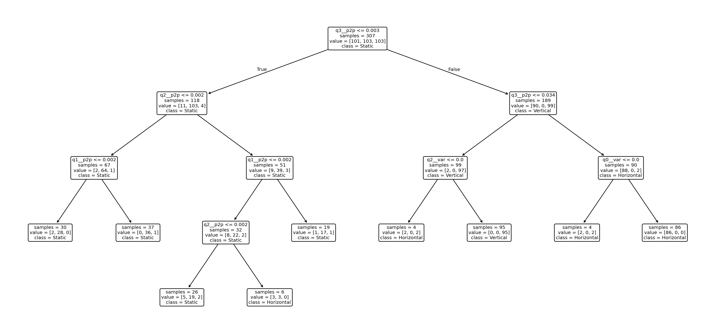
Figure T7-2. Decision-tree structure generated from the 120 Hz QUAT+FE dataset.

5. STM32F401RE reception and UART
The generated STM32 `algo_builder.c` calls Sensor_Hub_Init(0,120,2,3) and ISPU_Init(64). The Sensor_Hub_Handler path in `ab_sensor_hub.c` selects the ISPU register bank and reads all 64 DOUT bytes through the IKS4A1 BSP register API (timer-driven polling). The activity-class ID is extracted at byte offset 40; the UART/display layer sends the selected values to MEMS Studio.
In `com.c`, `Usart_BaudRate = 921600`; `USARTConfig()` configures 8 data bits, 1 stop bit, no parity and no hardware flow control. Actual packets use HAL_UART_Transmit with framed/binary MEMS Studio protocol, not plain-text terminal messages. The corresponding code evidence is bundled.
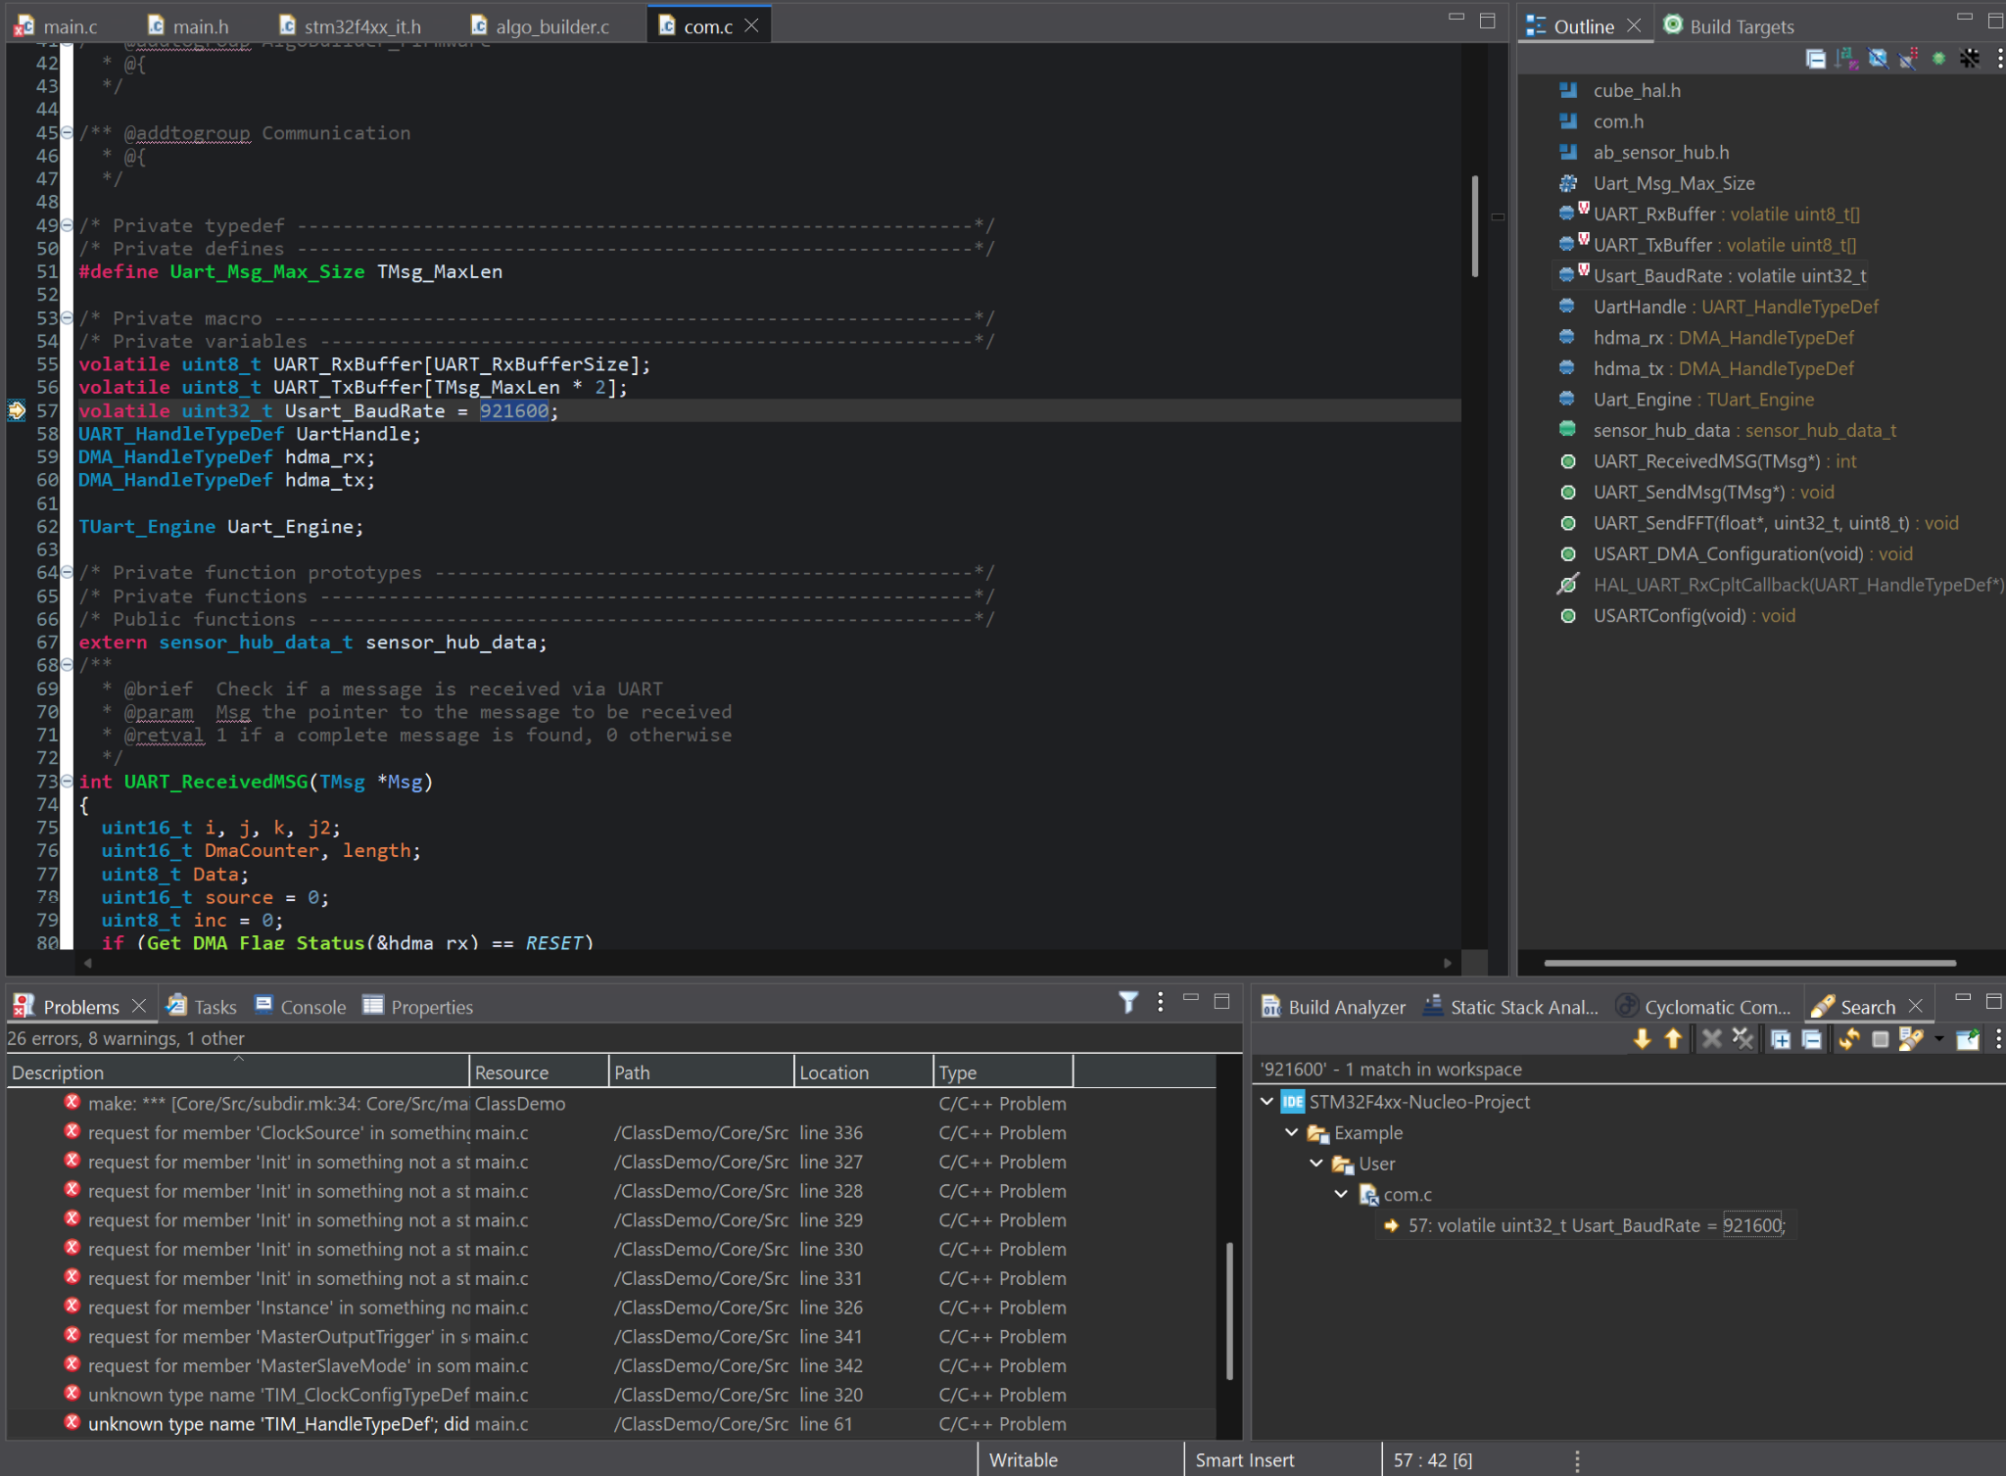
Figure T7-3. STM32CubeIDE code showing the configured 921600 baud value.

6. ISPU memory utilization
Section | Bytes | KiB | Meaning
text | 21932 | 21.418 | ~66.93% of 32 KiB ISPU program memory
data | 108 | 0.105 | Initialized variable section
bss | 784 | 0.766 | Uninitialized variable section
data + bss | 892 | 0.871 | ~10.89% of 8 KiB ISPU data memory
dec | 22824 | 22.289 | Sum of ELF sections, not one bank
These are the final STRED `stred-size` figures reported from the successful ISPU build. They exclude complete runtime stack/high-water usage. STM32 FLASH/RAM overhead must be extracted from the STM32 ELF/MAP after building the actual generated project; it is not represented by this ISPU size output.

7. Benchmark table: measured vs. outstanding
Quantity | ISPU implementation | STM32-only reference
Total processing time per sample | NOT MEASURED: INT2 active pulse needed | NOT MEASURED
Decision-tree-only traversal time | NOT ISOLATED | NOT MEASURED
CPU cycles / sample | NOT MEASURED: requires timing and ISPU clock | NOT MEASURED: DWT required
Program/data memory | 21.418 / 0.871 KiB | NOT MEASURED: MCU ELF/MAP
Power | Sensor-only baseline below; total unavailable | NOT MEASURED
Power baseline: ST DS13892 specifies approximately 595 µA for combined accelerometer and gyroscope high-performance operation at VDD=1.8 V (ISPU current excluded). Therefore, sensor-only typical baseline power is ~1.071 mW. This is not the measured or estimated total power of the running application. Do not compare this baseline with an STM32-only full-system number.
For total ISPU active time, AN5799 §9.9 describes routing the ISPU sleep indication to INT2; its inactive pulse duration reflects processing time. A benchmark-only conf.txt is supplied. Record measured LOW-pulse widths, ISPU clock and current assumptions in the benchmark worksheet; then compute cycles and duty-cycle-based power. Run an STM32-only reference with DWT instrumentation for an apples-to-apples comparison.

8. Real-time hardware demonstration and limitations
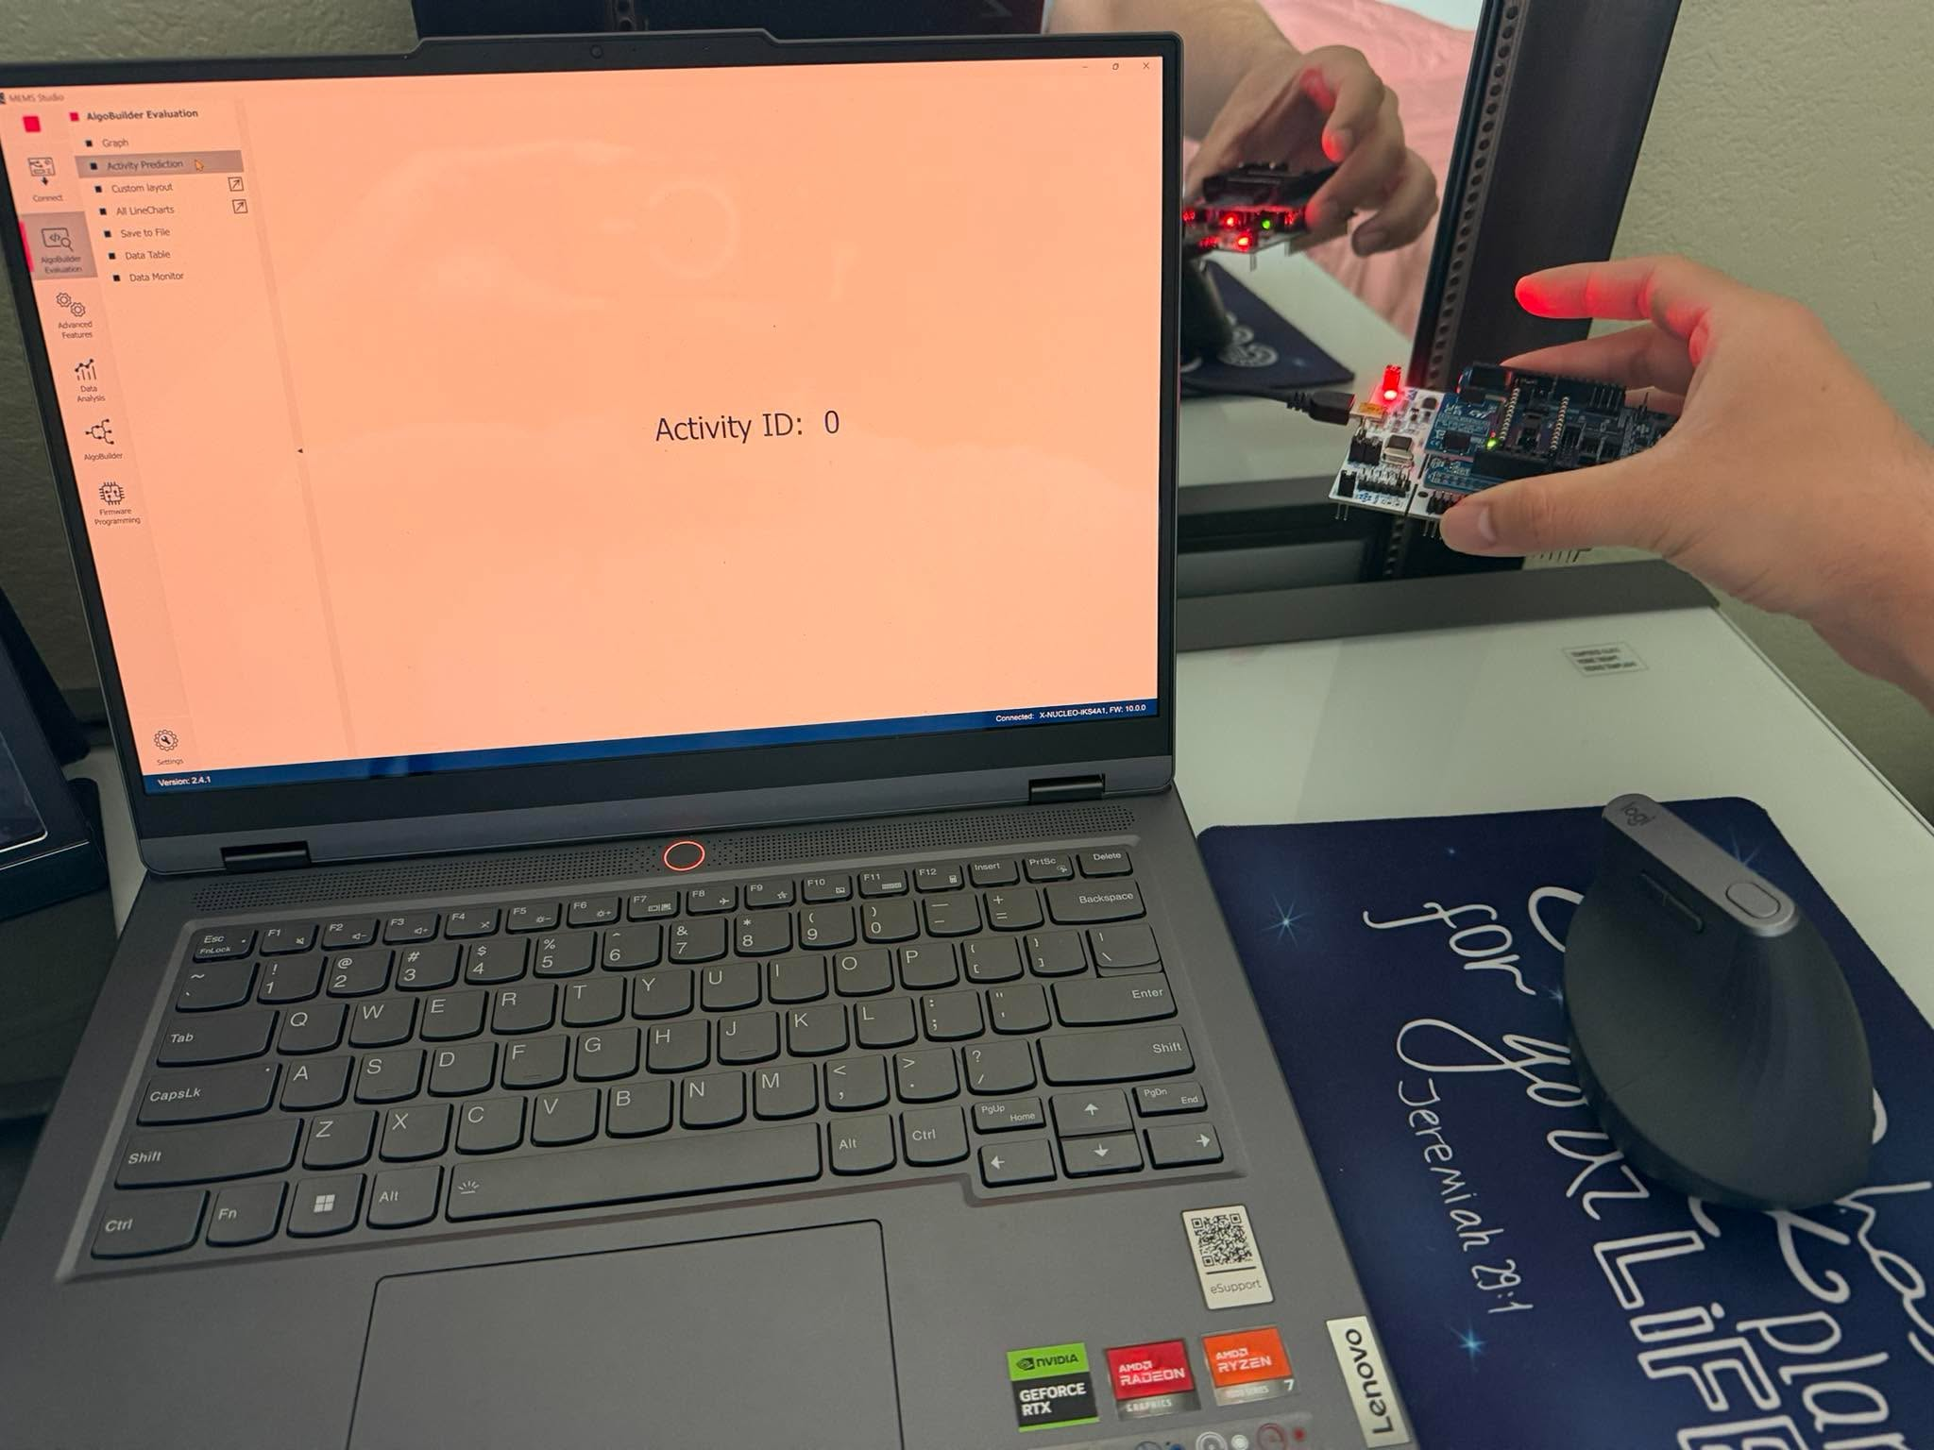
Figure T7-4. Representative live MEMS Studio classification with the physical NUCLEO/IKS4A1 board (Activity ID 0).
Live demonstrations were reported successful for classes 0, 1 and 2; photographs and graph screenshots are included in folder 06_Hardware_Evidence. Observing changing class IDs verifies execution and communication, but not a quantified out-of-sample hardware confusion matrix.

9. Submission status and remaining evidence
Expected output | Status
ISPU C source; compact QUAT+FE model header | INCLUDED
JSON training model; training/validation plots | INCLUDED
Working MEMS Studio native .mems / final plsworkv1.json | NOT AVAILABLE IN PROVIDED FILES — export working design
STM32 polling and UART integration source evidence | INCLUDED; full generated buildable workspace not provided
ISPU and STM32 memory report | ISPU INCLUDED; STM32 memory PENDING
ISPU vs STM32 latency / CPU cycles / power | WORKSHEET INCLUDED; hardware measurement PENDING
Python vs C offline agreement | 463/463 INCLUDED
Hardware-vs-reference confusion matrix | PENDING independent labeled sessions
Live screenshots | INCLUDED

References
[1] STMicroelectronics, LSM6DSO16IS datasheet DS13892, Rev. 2, June 2022, https://www.st.com/resource/en/datasheet/lsm6dso16is.pdf
[2] STMicroelectronics, AN5799, LSM6DSO16IS application note, Section 9.9 (INT2 active-time monitoring), https://www.st.com/resource/en/application_note/an5799-lsm6dso16is-alwayson-3axis-accelerometer-and-3axis-gyroscope-with-ispu--intelligent-sensor-processing-unit-stmicroelectronics.pdf
[3] User-provided MEMS Studio 2.4.1 generated source: algo_builder.c, ab_sensor_hub.c, and com.c; final STRED `stred-size` output.
[4] Task 7 model development artifacts: retrain_task7.py, evaluation_results.json, tests/verify_c_matches_python.py, host_validation_output.txt.

